**Mastering Fractions: A Guide to Multiplying and Dividing**

Understanding fractions is a fundamental part of mathematics, and learning how to multiply and divide them is crucial for students. This article will help you master these skills with step-by-step explanations and visual examples.

**Multiplying fractions by whole numbers**

Let's imagine you have a pizza that is cut into 8 equal slices. If you take 1 slice, the fraction representing the amount of pizza you have is 1/8. The number on top (the numerator) shows how many slices you have, and the number on bottom (the denominator) tells you how many slices make up the whole pizza.

What if your friend felt extra generous and gave you more pizza slices? Now you have 4 times as many slices as you had originally. To represent that, we **multiply the numerator** by 4

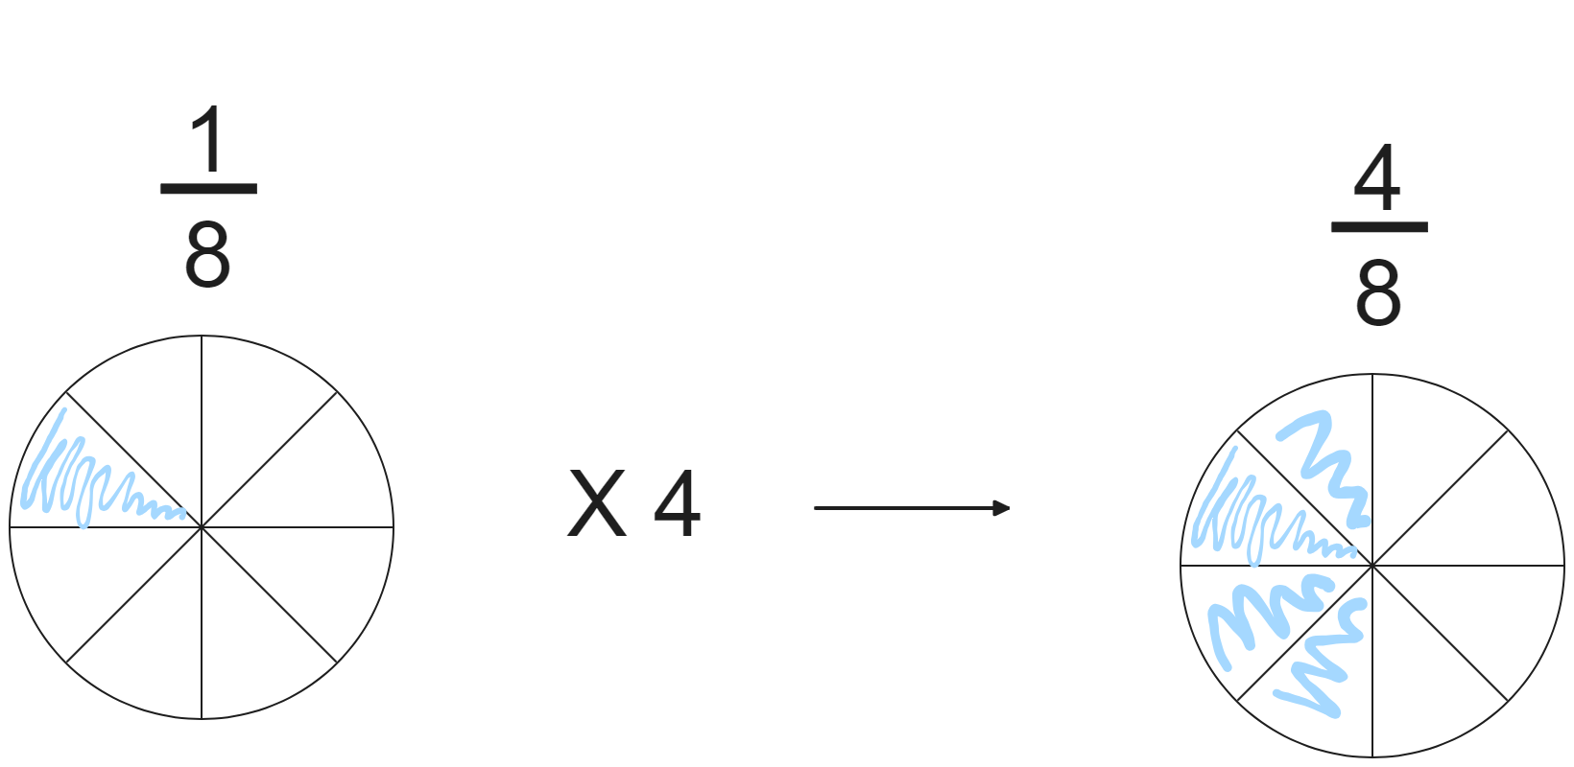

Therefore, it is clear that to multiply a fraction by a whole number, we must **multiply the fraction's numerator by the whole number**.

**Multiplying fractions by fractions**

Let’s consider the expression,

$\frac{3}{8 } × \frac{1}{2}$

Let’s try to solve this using the pizza example. You have 3 pizza slices, which represents 3/8 of the whole pizza. Now, you want to share half of your 3 slices with a friend.

Here's how you can do it:

1. Take your 3 slices and cut each into two equal parts.
2. This will give you 6 smaller slices, each representing 1/16 of the whole pizza.
3. Since you're giving your friend half of your original 3 slices, you'll give 3 of these smaller 1/16 slices.

Therefore, $\frac{1}{2}$ of $\frac{3}{8 }$ is $\frac{3}{16}$

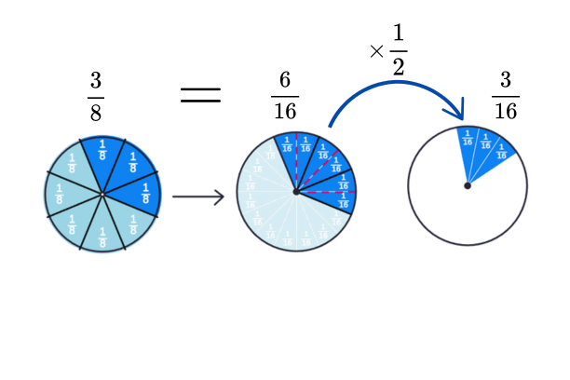

In general, to multiply two fractions we multiplythe numerators and denominators of each fraction together. Using our pizza example:

$\left(\frac{3}{8}\right)×\left(\frac{1}{2}\right)=\frac{3×1}{8×2}=\frac{3}{16}$

**Dividing fractions by fractions**

When we divide whole numbers, such as 10 divided by 5, we are essentially asking, "How many groups of 5 are there in 10?" In other words, we want to know how many times 5 can fit into 10.

We can approach dividing fractions similarly. Consider the following division:

$\frac{2}{3}÷\frac{2}{6}$

**Using a pie analogy:**

Imagine we have two pies. One pie is divided into 3 equal slices and the other into 6 slices.

We want to compare 2 slices from the pie with 3 slices to 2 slices from the pie with 6 slices. How many parts of $\frac{2}{6}$ can fit into $\frac{2}{3}$?

By inspection, the answer is 2, as we can fit it two times in the 3-slice pie. Hence, we have that:

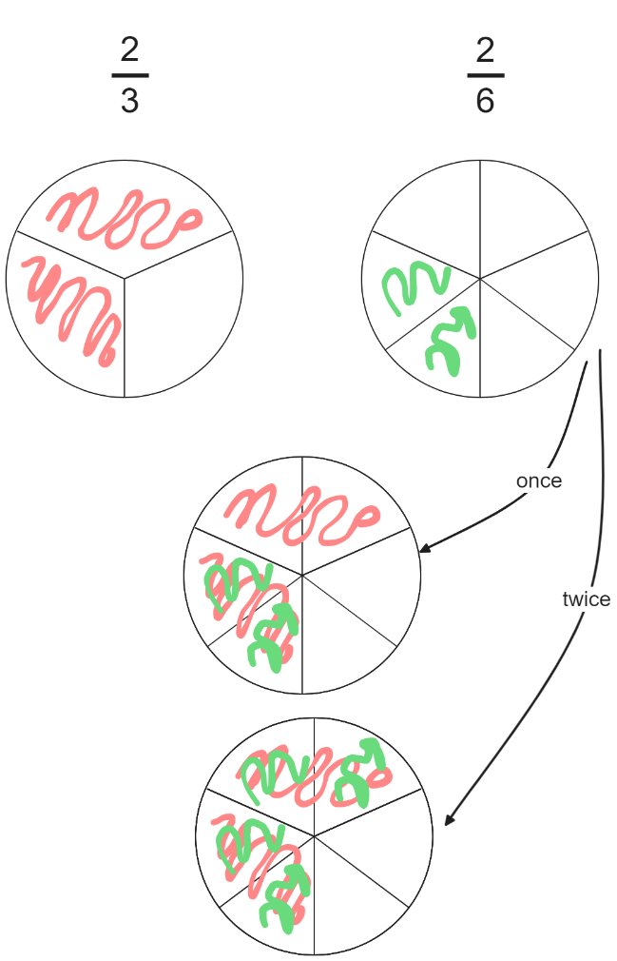

By inspection, the answer is 2 as we can fit it two times in the 3-slice pie. Hence we have that:

$\frac{2}{3}÷\frac{2}{6} = 2$

This visual approach becomes inefficient for more complex fraction divisions.

Instead, we can make a simple adjustment to convert division to multiplication.

**Step 1: Obtain the reciprocal of the divisor**

The reciprocal of a fraction is found by inverting or flipping the numerator and denominator. For example, the **reciprocal** of $\frac{2}{6}$ is $\frac{6}{2}$. Note: When working with whole numbers, we treat them as fractions with a denominator of 1 so the reciprocal of 6 is $\frac{1}{6}$.

**Step 2: Multiply the fractions**

Now you can multiply the dividend by the reciprocal of the divisor obtained in step 1 to obtain the final answer.

Let’s calculate the answer $​\frac{2}{3}÷\frac{2}{6}$ using the reciprocal. Instead of dividing $\frac{2}{3}$ by $\frac{2}{6}$ directly, we can multiply $\frac{2}{3}$ by the reciprocal of $\frac{2}{6}$, which is $\frac{6}{2}$ to get the answer.

$\frac{2}{3}÷\frac{2}{6}=\frac{2}{3}×\frac{6}{2}=\frac{12}{6}=2$